**PROJECT ABSTRACT**

Fitness Tracker:

User

1. User inputs name, gender, weight, and age

Strength/Conditioning

1) User selects what area to workout.

a. Upper

b. Core

c. Lower

2) User selects a level of workout.

a. Upper - level 1 - 15 pushups, 15 pullups

b. Upper - level 2 - 30 push ups, 30 pull ups

c. Upper - level 3 - 45 pushups, 45 pull ups

d. Upper - level 4 - 60 push ups, 60 pull ups

e. Upper - level 5 - 75 push ups, 75 pullups

f. Core - level 1 - 15 sit ups, 15 second plank

g. Core - level 2 - 30 sit ups, 30 second plank

h. Core - level 3 - 45 sit ups, 45 second plank

i. Core - level 4 - 60 sit ups, 60 second plank

j. Core - level 5 - 75 sit ups, 75 second plank

k. Lower - level 1 - 15 squats, 15 lunges

l. Lower - level 2 - 30 squats, 30 lunges

m. Lower - level 5 - 45 squats, 45 lunges

n. Lower - level 5 - 60 squats, 60 lunges

o. Lower - level 5 - 75 squats, 75 lunges

3) Keep track of which workouts have been completed.

Cardio

1). User selects level of workout

a. Easy

b. Moderate

c. Advanced

2). User selects duration (in minutes)

a. 15

b. 30

c. 45

d. 60

3). Keeps track of total duration and calories burned

**DESCRIPTION OF DIVISION OF LABOR**

Nicole Moody – Graphic Design, Layout Design

Cyrus Champagne – Layout Design, QC/QA

Caliyah Kappel – User Interface, Partial Programming

**UML USE CASE**



**DESCRIPTION OF UI**

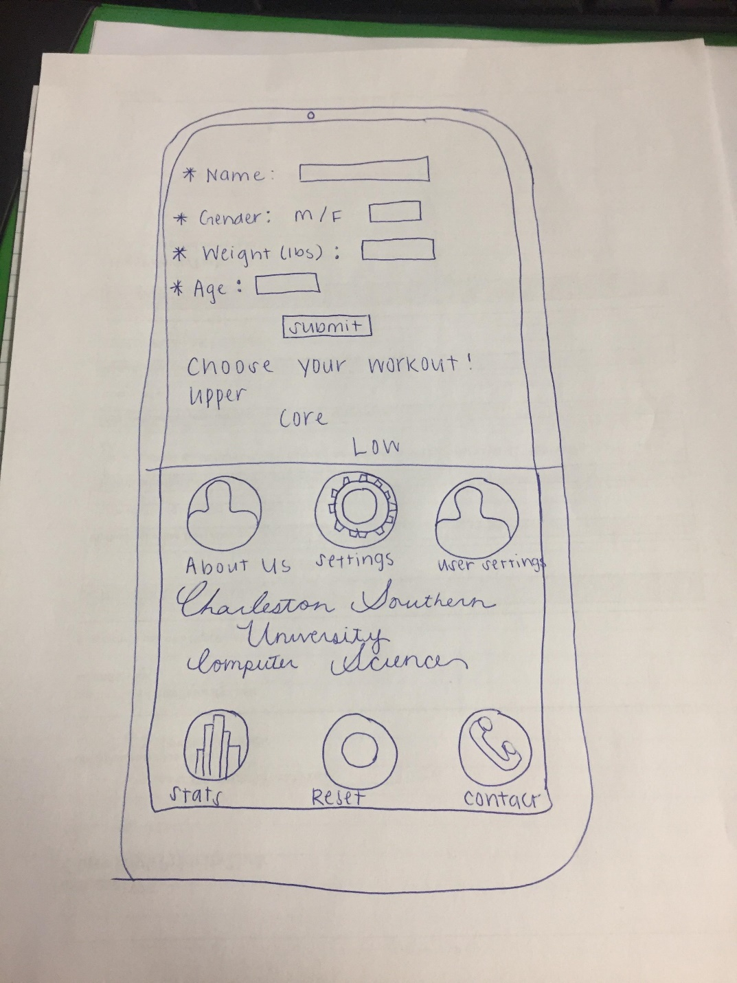

All, attached is a simple sketch of the UI. Cyrus, Nicole and I worked on it today. All Dr. West wanted was a simple explanation of how the program would appear.

* Caliyah Kappel